Guided Practice Report
Before completing this guided practice report, you should have completed the associated procedure.

Screenshots
After you have completed the procedure for the guided practice, add your screenshots below.
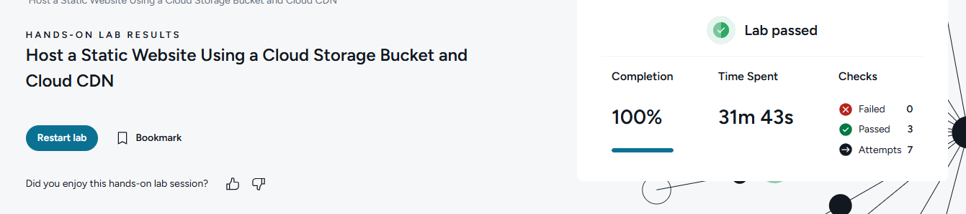

Reflection Questions
After you have completed the procedure for the guided practice, provide your answers to the reflection questions here.
Google Cloud Storage guarantees 99.999999999% durability. What does durability mean as it relates to data storage?
Durability in data storage means how reliably data is preserved over time without being lost. Google Cloud Storage’s 99.999999999% durability means your stored data is extremely unlikely to be lost.

How do the Google Cloud Platform (GCP) data storage location options differ from those in AWS? How are they similar?
GCP vs AWS storage locations
- GCP: offers regional, dual-region, and multi-region storage options.
- AWS: offers regions and availability zones, with services like S3 using multiple AZs automatically.
- Similarity: both let you choose where data is stored for performance, redundancy, and compliance.

How does GCP Fine-grained access control differ from Uniform access control?
Fine-grained vs Uniform access control in GCP
- Fine-grained: permissions can be set individually on objects and buckets.
- Uniform: permissions are managed only at the bucket level using IAM, making administration simpler.

